# Invoice Approval Automation (DRAFT)

## Mail Notifications

1. Mail Notifications are sent to the Consultant once a month on defined date, e.g. 15th of every month.

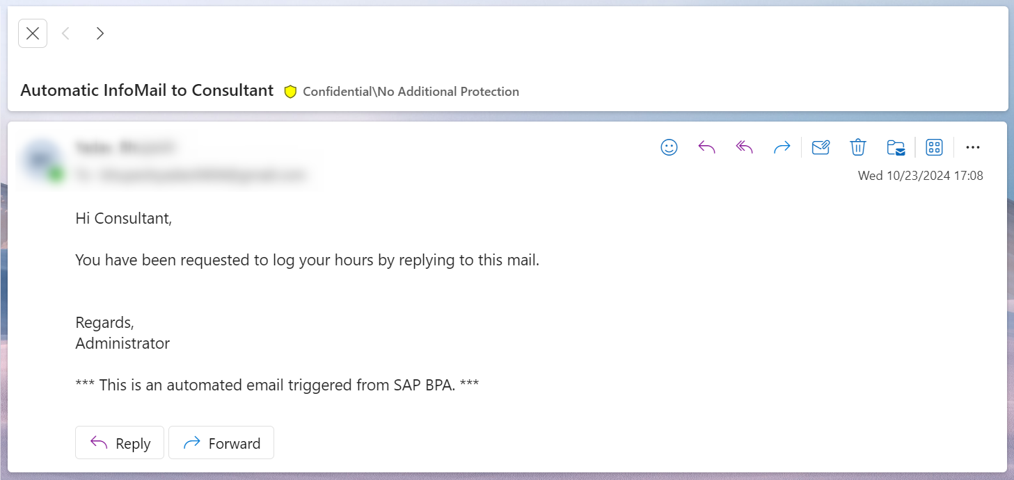

1. If a consultant doesn’t reply within defined SLA, a reminder mail is sent. For the testing, it was determined as 2 minutes.

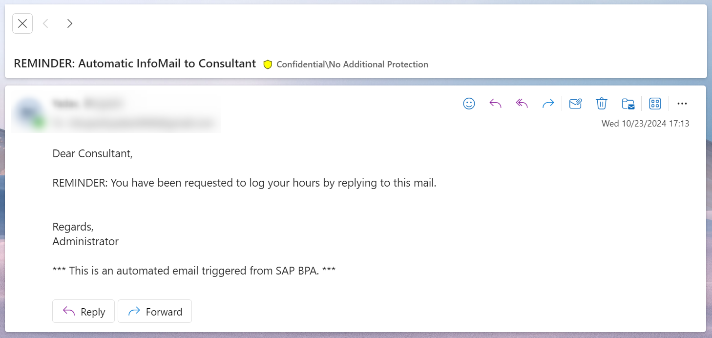

1. Automation runs every 15 minutes to see if there has been any reply on the mail.
2. If there has been no reply, nothing happens.
3. When there’s a reply, automation tries to fetch the attachment in the mail.
4. If the reply has attachment in PDF or excel format, automation sends a successful confirmation to the consultant.

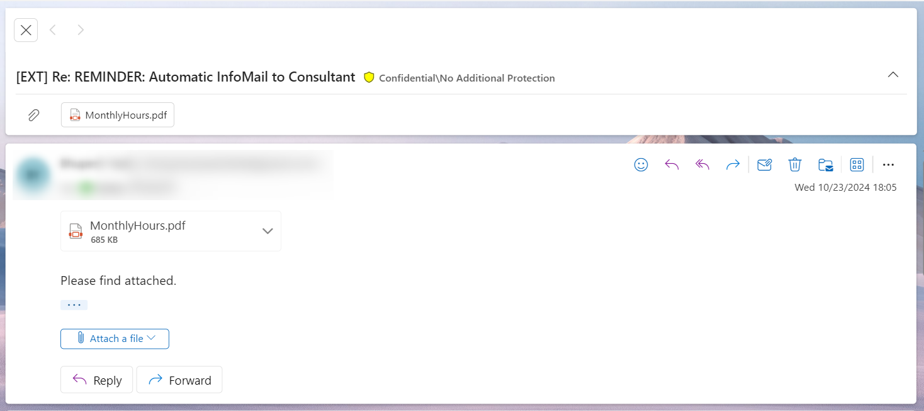

Reply from Automation –

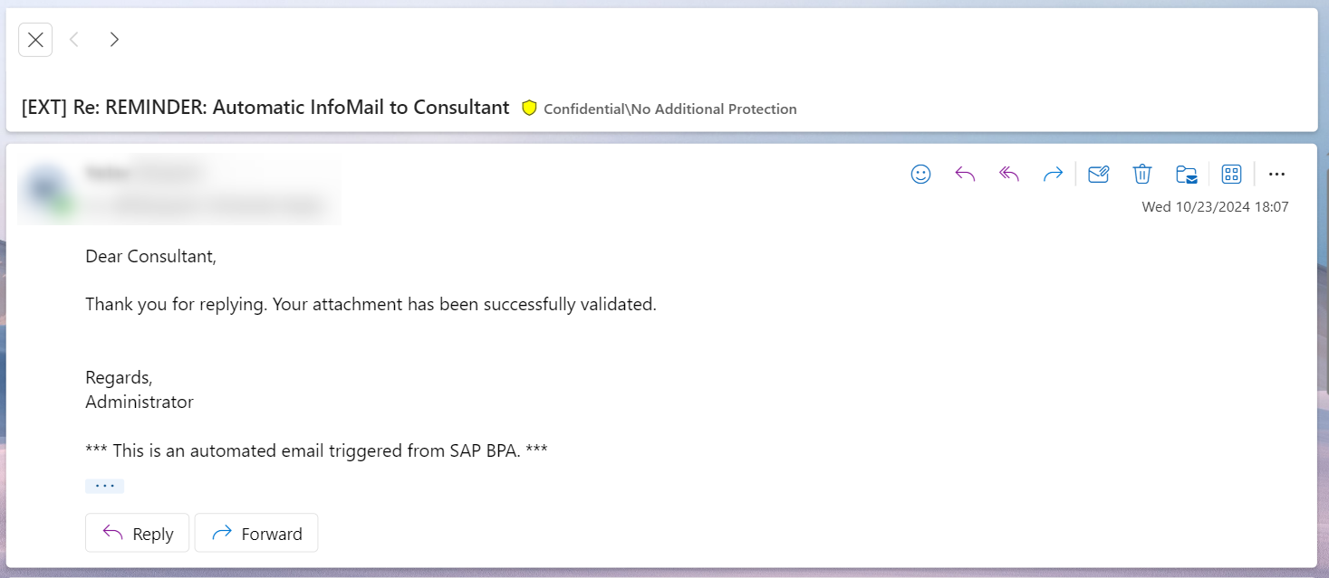

1. If there’s no attachment, automation replies to the consultant asking them to send an attachment with their replies.

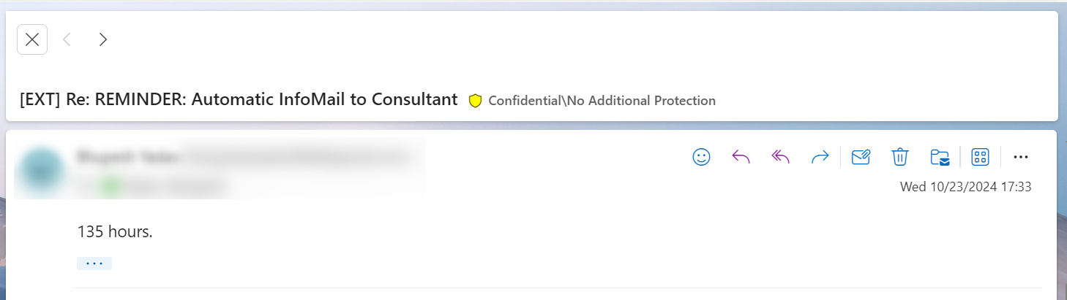

Reply from Automation -

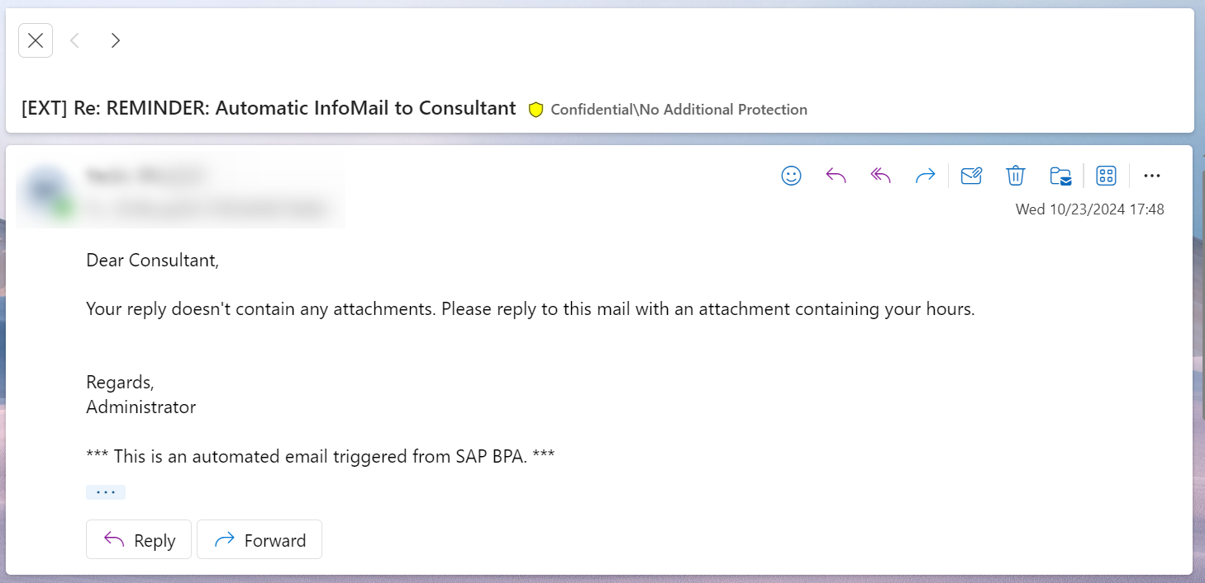

1. If the attachment has an attachment other than a PDF or an excel, automation replies to the consultant asking them to send the correct file.

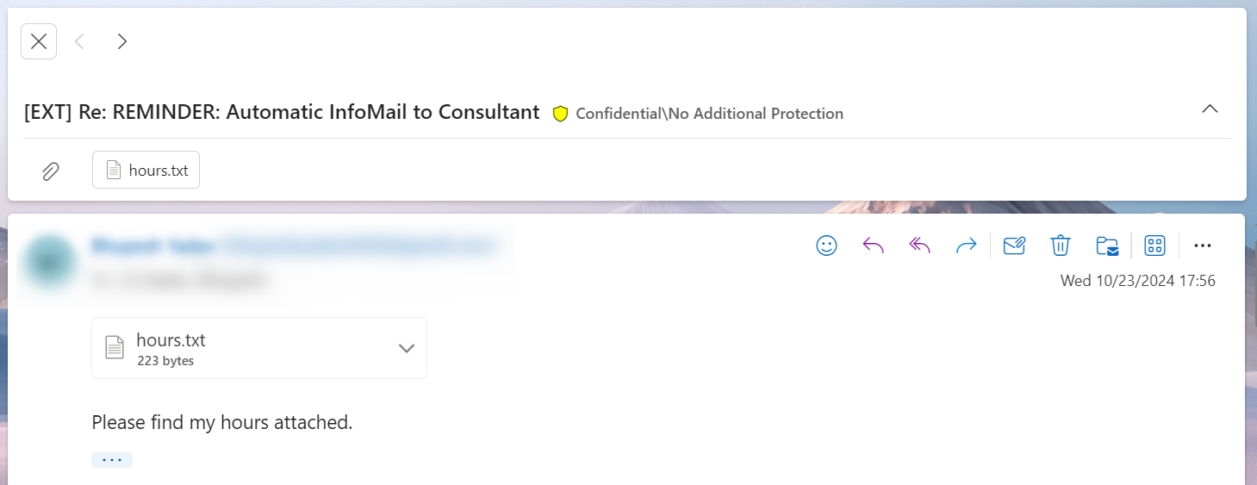

Reply from Automation –

